**Overview of Mass Storage Structure**

Moss desktops still use **magnetic disks**.

**Transfer rate**: rate of data transfer.

**Positioning time**: time to move arm.

**Seak time:** Once arm is in correct position, disk must spin till at correct area of storage.

**Head crash:** If the head touches surface (unintentional), changes data/damages disk.

SAS (serial attached Scuzzy )+ fibre channel : Most popular server environment bus.  
While for home use, SATA.

**Disk controller:** Built into disk,it talks to computer **host controller**.

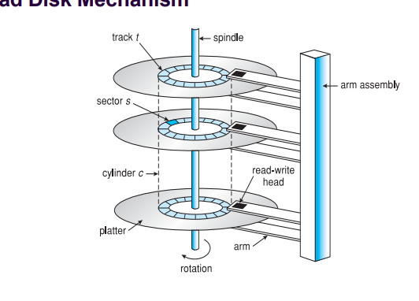

**Block:** It is a circular track, broken up into smaller pieces called a sector. Multiple sectors on multiple disks, is called a cylinder.

We use a cylinder, as you can have multiple arms reading at once for a request, speeding up data flow.

**SSDs:** much faster, more expensive + lower lifespan

**Magnetic tapes:** Archival storage

**Storage array**

**Storage Area Network**

Dedicated network that only focusses on storage data. So only storage data is transferred through hit.

**Network Attached Storage**

This where NAS is storage available over network (as if a D drive)

Advantage: Have a lot less equipment to maintain.

Disadvantage: Depending on how much data is transferred, can cause bottlenecks/slow.

**Disk Scheduling**

**Disk Request:** When reading or writing to file, requests happens. The OS or controller handles these requests in a certain order. This is called **disk scheduling.** There are different algorithms to handle these requests.

**FCFC –** Frist come first serve.

This is not good, as disk will have to move a lot to reach each area of storage.

**SSTF Short seek time algorithm**

Looks at queue of requests, look at where you start, and looks at how you can order them to move the least. Ie One closest to starting one eg 53, then 63 is closest.So move to that one, repeat.

**SCAN**

Goes all the wat down to 0, then all way to top, servicing requests on the way.

**C-Scan**

Services requests as it goes to end. Once at end, goes to start without servicing requests. Then Repeat servicing requests from 0 to end.

**C-Look**

Same as C scan, but stops at highest and lowest request.

**Exercises: (These are asked in exam NBNBNB]**

**Hypthetial disk with 2 cylinders [0-24]**

**Currently at cylinder 17**

**Requests come in for: 16 - 13 – 19**

**FIFO:** 17 - 16 – 13 – 10 Efficiency = [17-16] + [16-13] + [13-19] = 1 + 3 + 6 = 10

**Requests come in for: 16 - 12 – 19**

**SSTF:** 17 – 16 – 19 - 12 Efficiency = [17 – 16] + [16-19] + [19-12] = 1 + 3 + 7 = 11

**SCAN:** 17 – 16 – 12 – 0 – 19 = [17-0] + [0-19] = 17+19 = 36

**LOOK:** 17 –16 - 12 – 19 = [17-12] + [12-19]= 5 +7 = 12

**Disk Management**

**Low level format:** In the factory, it describes the number of tracks, and number of sectors for tracks. Each sector has a header to tell where it starts.

The OS/File system then takes the system and re-arranges it into the system partitioning that we use.

**Disk IO** done in blocks.

**File I/O** done in clusters (number of blocks).

**Boot block**: First block on disk storing boot strap program. ROM on hardware starts that boot block.

**Sector Sparing:** Used to handle bad blocks. So when a bad sector is detected, it unlocks one of these spare sectors for use.4